What am I testing for? | Test data | What I expect | What actually happened | What I changed
Testing that access is restricted from user if not logged in | Ill attempt to enter a page I shouldn’t be allowed to | Redirect me to index and display a message telling me I need to be logged in |  | N/A
Testing that login works and that it outputs a log to audit table | Logging into account name a password 123 | Log me in and add log to audit table |  | N/A
Testing that it will allow me to log out and adds a log to audit table | Clicking logout |  |  | N/A
Testing that it will allow me to register a new patient and add it to audit log | b,a,c,123,m,12 | Create a new patient named b with the password 123 | 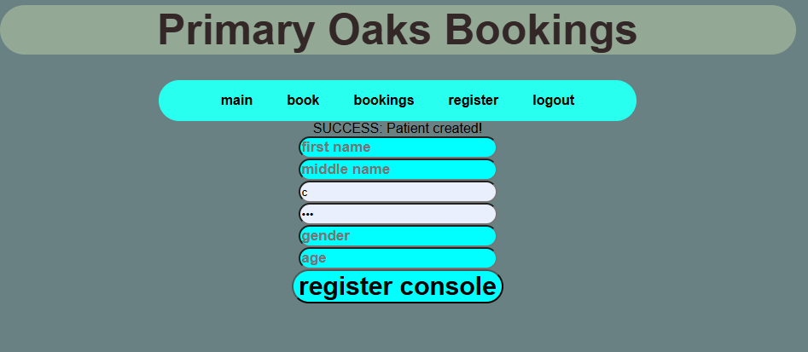 | N/A
Testing password checker doesn’t allow me to create a user below strength of 7 | bab,a,c,123,m,12 | Fail to create a user and tell the patient what things they missed | 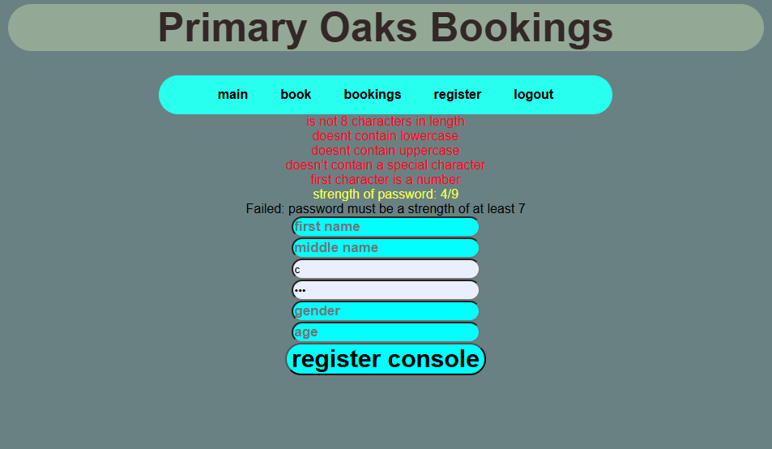  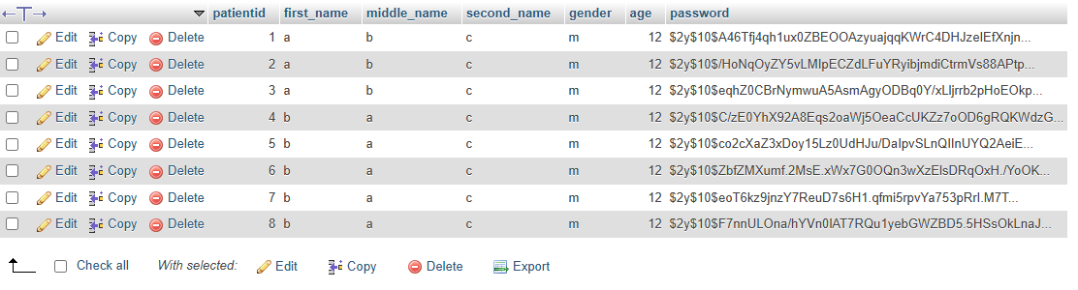 | N/A bab wasn’t added so nothing needs to change
Testing password checker allows me to create a user when password is 7 | Bab,a,c,1PiKachu!,m,12 | Create a user with a stength password of 7 named bab | 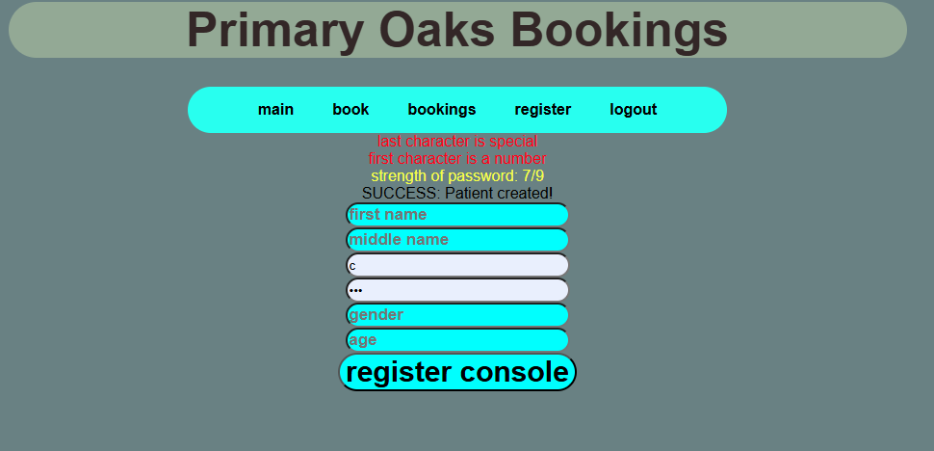 | N/A bab was created and added to patients

